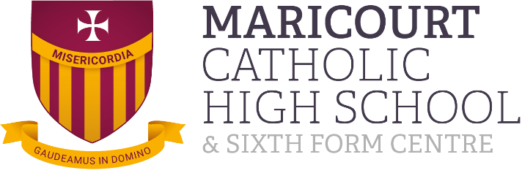

MARICOURT CATHOLIC HIGH SCHOOL
Hall Lane, Maghull, Merseyside, L31 3DZ
Telephone 0151 330 3366; Fax 0151 284 6631
E-mail: Recruitment@maricourt.net
Maricourt Catholic High School is a
Co-Educational Comprehensive 11-18 Voluntary Aided School
1100 on roll (107 in Sixth Form)
Teacher of Maths from 1st September 2026 to 31st August 2027 (Fixed term)
MRP1 to UPS3
We are seeking to appoint a creative and inspiring full-time Teacher of Maths (Fixed term) from 1st September 2026 to 31st August 2027 with excellent classroom skills. You will be expected to teach across the full age and ability range with the possibility of A level. The successful candidate would be joining a highly supportive department. This post may be suitable for someone early in their career.
Maricourt is committed to the safeguarding of its students. Enhanced due to the nature of the work, the post is exempt from the Rehabilitation of Offenders Act 1974 and the successful candidate must be able to obtain a satisfactory Enhanced Disclosure (via the Criminal Records Bureau) in order to be appointed to the post. Due diligence will be undertaken as part of the recruitment process.
Job description and application form available on our website: www.maricourt.net under vacancies.
Closing Date: Friday 30th January at 9:00am
No CV’S. Completed applications to be returned to Recruitment@maricourt.net

