

Special Education Needs & Disability

Autumn 2022 – NEWSLETTER

MAricourt newsletter

December 2022

Dear parents/carers,

Welcome to all our new families, to our Maricourt SEND community. My team and I have had another busy term getting to know and supporting our students with SEND to access the curriculum and make the most of the opportunities on offer at Maricourt. All students with SEND have a key worker /key teaching assistant at school who will have been in regular contact with yourselves to provide the go between contact for concerns you may have had with pastoral/curricular or SEND issues. I hope you have found this communication useful

As SENDCo I have worked closely with out teaching staff to ensure teaching is adaptable to the needs of our students, as is our behavior policy. As classroom teachers we make reasonable adjustments to ensure an all students reach their potential irrespective of any disability they may have. We also work closely with our wellbeing team and chaplain- Julia, to provide bespoke social and emotional support. To this end, we have continued our collaboration with Autism Initiatives who offer the personalised and specialist support, many of our students with Autism need.

Next term I hope to continue with our parent coffee mornings supported by external agencies as well as our parent SEND forum. If you would like to be part of this please email me.

I’d like to add that both myself [cowansj@maricourt.net](mailto:cowansj@maricourt.net) and my admin assistant Mrs Byrne [byrnec@maricourt.net](mailto:byrnec@maricourt.net) are available for any concerns/worries you or your child has.

*Finally, myself and the SEND team would like to wish you all a very happy and peaceful Christmas.*

Many Thanks,

Jo Cowans (SENDCo)

**DATES FOR YOUR DIARY**

* 31st December – Webinar – Witherslack Group – The Special Educational Needs Podcast
* Wednesday 4th January – Term starts
* 5th January – Year 11 Parents Evening
* 19th January – 6th Form Parents’ Evening
* 31st January – Webinar – Witherslack Group – EHCPs Explained
* 8th February – Year 9 Options Evening
* 2nd March – Year 9 Parents Evening
* 16th March – Year 8 Parents’ Evening
* 30th March – Year 10 Parents Evening



### A Person with Autism or Autistic?

There is an ongoing debate over how people with a diagnosis of autism wish to refer to themselves and/or their diagnosis. The phrase ‘person with autism’ (person first) is used frequently in literature, but more recently, there has been a return to the use of the term ‘autistic person’ (or identity first), language driven by the autistic 'community'. This is to recognise the fact that autism is an integral part of a person and nothing to be ashamed of.  When talking to people, we will use the words preferred by the person to describe themselves. When we write, we will use both ‘person with autism’,  ‘autistic person’ or 'person on the autism spectrum'. We recognise that people can feel strongly about both terminology and language and whilst we do not wish to cause any offence to anyone, we will always prioritise the views of autistic people themselves.  This is the 'AI Way'!

Autism Initiatives



# Autism and Social Communication Team, Parent /Carer Training Sessions.

# https://www.seftondirectory.com/kb5/sefton/directory/site.page?id=ZIkY7JHXSGs

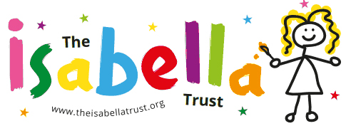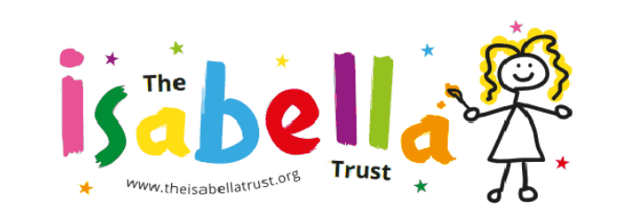

Welcome to The Isabella Trust

The Isabella Trust aim to **support** parents,

carers and families of children with **autism**

and **sensory difficulties** by providing support,

information and access to training, courses and workshops.





## **What we do**

## The AET is a partnership of autistic young people,

## parents/carers, academics and professionals.

## This, coupled with our approach to research and evidence-based resources, means that we have expert knowledge to share.

**Visit our website at https://www.autismeducationtrust.org.uk/**



***“At Witherslack*** *we provide inspirational education and care to children and young people, resulting in life changing experiences and countless stories of success. We are here to help you and your family, and our unwavering help and support can start right now.”*

## **We can help!**

We support parents and carers to navigate the journey of SEN with our resources and supportive team who are always on hand to help you and your family.

[**witherslackgroup.co.uk**](mailto:abc@def.com)



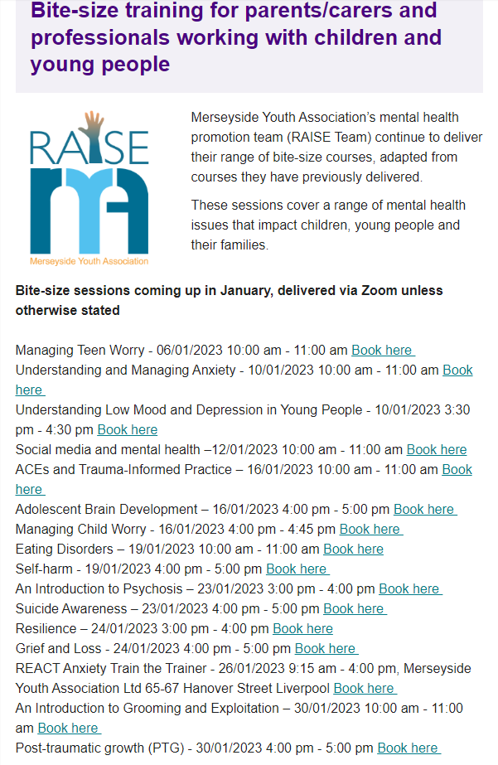

Sefton’s partnership newsletter - outlining the local emotional and mental health support offer over the Christmas period.  Please click the link below to ensure as many young people, families, colleagues and schools have sight and access to this before the holidays start.

https://mailchi.mp/a1413fe6bcb9/december-2022-newsletter-sefton-emotional-health-partnership

